|  |
| --- |
| Piping and valve system guide |
|  |
| User manual |

|  |  |  |  |  |
| --- | --- | --- | --- | --- |
| Date  5 October 2015 | Reference  018.60 | Version  0.1 | Status  Concept | Jelle Spijker  078-6910527  j.spijker@ihcmerwede.com |

Content

1 Introduction 3

2 Terminology, definitions and abbreviations 4

3 Global workflow 5

4 Description 6

# Introduction

The piping valve and system guide, for short a “piping guide”, is a project specific document which describes pipe specifications, joints, penetrations, valves and instrumentation which are used on each project. The piping guide find its origin at O&M where diagram specialist created a guideline for commonly used situation. This guide was adopted by Dredgers and changed according to their specific needs.

These guide where combined into one unified piping guide. Which is used by all IHC Holland build ships.

And are derived from a mother piping valve and system guide and notes for commonly used diagrams. This piping valve and system guide, for short a “piping guide”. C

## The purpose and intended audience for this manual

This manual is written to ensure proper handling of the piping guide and therefore safeguard its quality. The piping guide differentiate between three types of users, namely:

* End users – A user that implements specifications which are given in a project piping guide. These user will most likely be diagram specialist and pipe routers.
* Super users – A user that creates and maintains the project related guide.
* Administrators – A user that maintains the mother guide and ensures proper handling of the project related feedback.

## Structure of this document

In chapter two the used terminology, definitions and abbreviations are described. Hereafter the global workflow and related procedures are explained in chapter three. In the sequential chapters four till six

# Terminology, definitions and abbreviations

# Global workflow

# End-user manual

The end user is a person who has read-only rights to a project related piping guide. He uses the information in the piping guide to build, design and check systems on a project.

## Location of the project related piping guide.

The piping guide can be found in DMS for each project as a pdf file. It can be found under number **018.16** or under the description  **IHC Piping and valve guide**.

## Description and legend of the piping guide

The front page of the piping guide is a standard frontpage. It describes the following aspects:

1. Title
2. Project number
3. Customer
4. Revision control

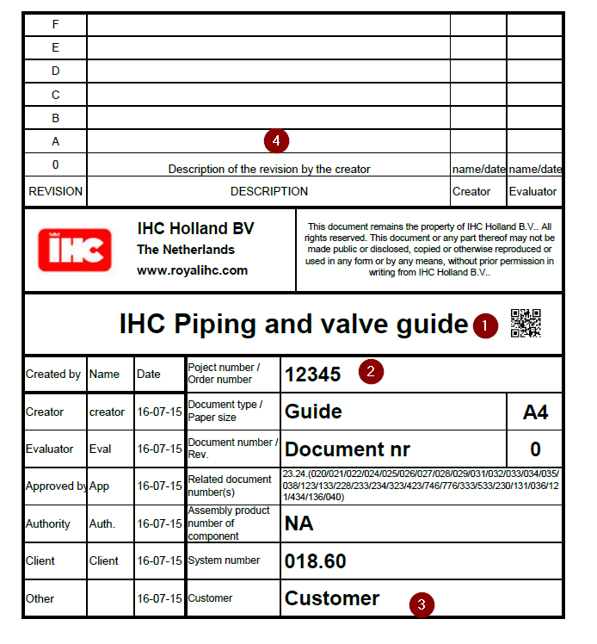

The second page is the index. The index list all the systems that are used on the project. The following aspect are described on the index:

1. Title
2. Current revision
3. Project number
4. Classification society
5. System identification number
6. Description and title of a system
7. Pipes section of a system
8. Valves section of a system
9. Instrumentation section of a system
10. Notes section of system
11. Dredgers system numbering
12. O&M system numbering

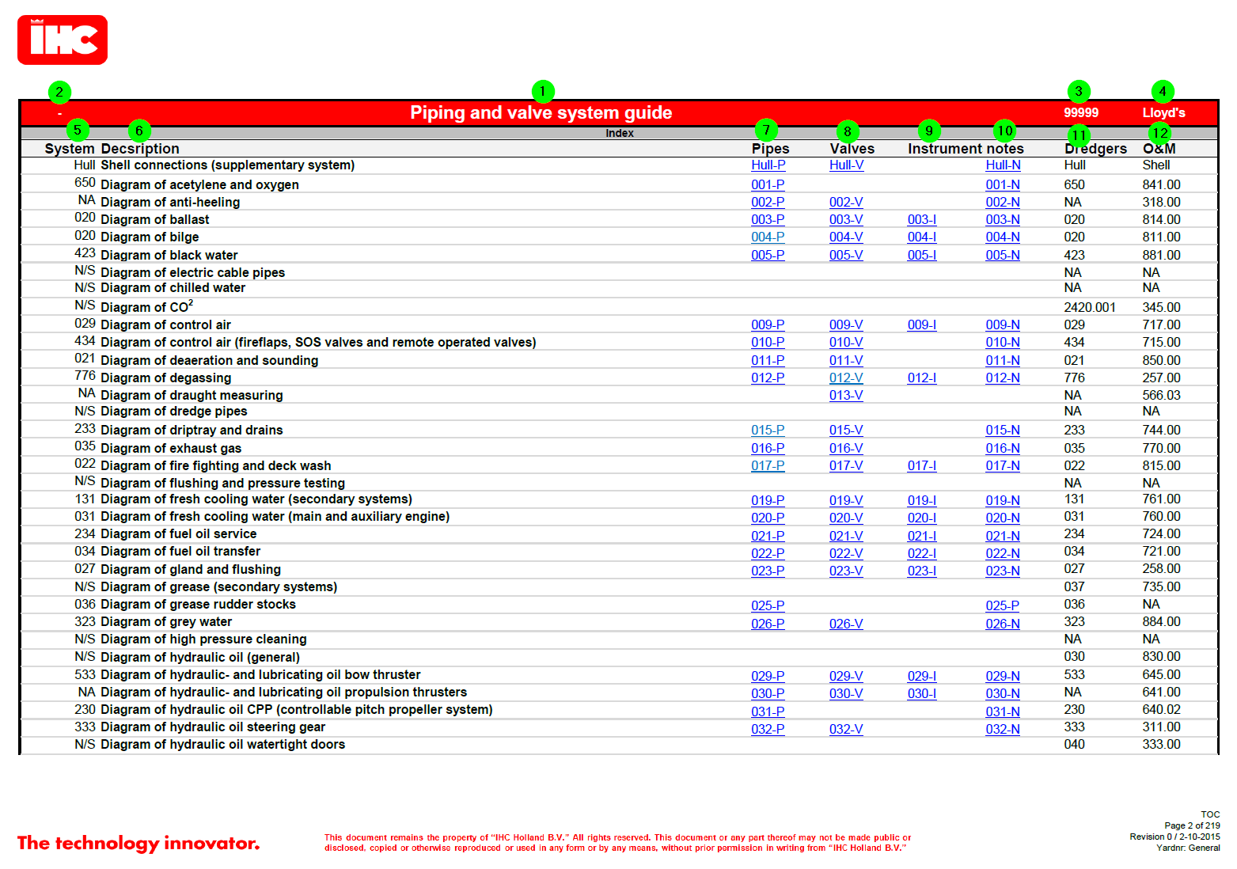

# Super user manual

# Administrator

# Project piping guide